Achal Gupta

A00258772

Abstract

Study proves the success of pain treatment and analyse its impact on the society.

Final Report

Success of Pain Treatment

Table of Contents

1. Introduction 3

2. Methods 3

3. Analysis 4

3.2 Patient Demographics and Characteristics 4

3.3 Success of Pain Treatment 5

3.4 Dependence of success of treatment on Age and Gender of patients. 8

3.5 Effect of other illness on the success of treatment 10

3.6 Impact of pain on Employment Status of patients 12

4. Conclusion 12

Appendix A: McGill Pain Questionnaire Sample 13

Appendix B: Roland Morris Disability Questionnaire Sample 14

Appendix C: Data Sample 15

Appendix D: Categories of Employment Status 15

Appendix E: Data Manipulation report 15

Appendix F: Descriptive analysis for Primary Analysis 15

Table of Figures

Figure 1: Scatterplot of Pain Score before treatment vs after 5

Figure 2:Box plot of Pain Score Reduction of two Groups 6

Figure 3: Scatterplot of AvgReduction vs Age grouped by Gender 8

Figure 4: Multiple pie chart- Proportion of other illness 10

Figure 5: Bar graph of Impact of pain on employment 12

Figure 6:Pie Chart of Impact of pain on employment 12

# Abstract

## Aim

The aim of this study was to examine the success of pain treatment on patients and analyze its dependency on factors like age, gender and existence of other illness in patients. Impact of Pain on the patient's employment status was also analyzed in the study.

## Methods

This study was designed as a retrospective observational study to evaluate the success of pain treatment between two different groups. Multi-centre, randomized, examiner and subject blind, two parallel-group designs were chosen for the study. McGill Pain score and Rolland Morris Pain score was documented at two-time intervals before and after treatment for the 110 patients who were given treatments at 7 different center locations across Ireland. Average of both the scores were then calculated at respective time intervals and was used to identify a reduction in pain.

## Results

Patients on an average reported pain at 5 different pain sites, maximum pain sites reported for the patient was 15. Average worst pain of 9.01, average present pain of 6.13, average all-time pain of 6.94 and average pain intensity of 7.35 was reported by patients at time interval T1 on a scale of 1 to 10.

On an average pain, the score was reduced by 2.78 units ranging from 1.29 to 4.23 with 95% confidence interval for the PGAP group of patients who were given the treatment while for the MTAU control group of patient average pain reduction was only 0.30 units. Treatment was not affected by the Age (P-value 0.483), Gender (P-value 0.614) and the existence of other illness (P-value 0.945) in patients.

Employment status of 65 or 73.07% of the patients was highly impacted due to pain while 22 patients have a comparatively lower impact while 2 of the patients shows no impact on the employment status.

## Conclusion

Treatment was successful in reducing pain in the PGAP group of patients and was independent of patients' age, gender or existence of other illness. Employment status of patients was highly impacted due to pain and thus the success of treatment will create a huge impact on the society.

# Introduction

A total of 110 patients were recruited for the study. Patients who were not able to fulfill the eligibility criteria were excluded from the study. Patients of different age, gender, marital status and level of education were recruited across various counties of Ireland. Patients were divided into two groups PGP and MTAU control group randomly. Patients were asked to fill the McGill Pain Questionnaire [Appendix A] and Rolland Morris Disability questionnaire [Appendix B] at two-time intervals T1 and T2 before and after treatment respectively. Refer [Appendix C] for data sample.

McGill Pain Index is the rating of pain developed by McGill University in 1971. It is the index which measures the intensity of pain patients are suffering. The patients are given 78 words in 20 sections and are asked to mark the words that best describe the pain. Sections 1-10 contains components related to sensory, Sections 11-15 Affective, Section 16 Evaluative and Section 18-20 is miscellaneous (Wikipedia, 2018). Rolland Morris score is a measure of pain where greater levels of pain are reflected by higher numbers on a scale ranging up to 24 points. The original version of the score was published in 1981. Patients are asked to read the list of 24 sentences and ticking appropriate questions based on how each sentence describe them today. (RMDQ, 2018).

# Methods

This was a Multi-centre, randomized, examiner and subject blind, two parallel-group studies conducted across 7 different counties in Ireland. Patients who have submitted a personally signed copy of consent form showing that they or their legal guardian has been informed of all aspects of the study were recruited and Patients who were diagnosed with diseases like HIV, CTS. Hepatitis C, diabetes, skin abnormalities at pain site areas were excluded from the study. Patients who were considered at risk of suicide or self-harm or a history of drug abuse were also excluded from the study. Pregnant women or patients enrolled in other studies within a month of start date were excluded from the study.

Patient demographics and history of other illness were extracted from medical records. Two questionnaires (McGill and Rolland Morris) were administered to patients at two-time intervals T1 and T2 for self-assessment of pain. Present Pain, Worst pain, average pain, and pain intensity was recorded for all patients on a scale of 1 to 10 at time T1. A number of pain sites for the patients were also recorded for individual patients at time interval T1. Patients were asked to state their employment status at time T1 which was later categorized to High, Low and No impact using the set criteria [Appendix D].

Recorded age of patients was calculated using the DOB column of the data set. T1AverageScore and T2AverageScore were calculated by taking an average of McGill and Rolland Morris score at time interval T1 and T2 respectively. AvgReduction was calculated by taking the difference of average scores at two-time intervals. AvgReduction column is used to determine the success of treatment in two groups of patients. NA values in average pain and pain intensity columns were replaced with corresponding mean values. T1EmploymentFinal describes the employment status of the patients while painSites describe the number of sites where the patient experiences the pain [Appendix E].

# Analysis

## Patient Demographics and Characteristics

The analysis population consists of 70.79 % of the Female population and 29.21% of male population. Mean age of the patients is 49.91, with youngest patient of age 25 years and oldest patient of age 70 years. 35.96% of the patient have a Degree level of Education and only 10.11% of the patients were postgrads. 57.30% of the patients were married, one of the patient was Divorced while only 29.21% of the patients were single. Patients on an average reported pain at 5 different pain sites, maximum pain sites reported for the patient was 15. Average worst pain of 9.01, average present pain of 6.13, average all-time pain of 6.94 and average pain intensity of 7.35 was reported by patients at time interval T1 on a scale of 1 to 10.

|  |  |  |  |  |  |  |  |  |  |  |  |
| --- | --- | --- | --- | --- | --- | --- | --- | --- | --- | --- | --- |
| **Variable** | **N** | **N\*** | **Mean** | **SE Mean** | **StDev** | **Variance** | **Minimum** | **Q1** | **Median** | **Q3** | **Maximum** |
| Age | 89 | 0 | 49.91 | 1.11 | 10.48 | 109.86 | 25.00 | 41.50 | 49.00 | 58.50 | 70.00 |

Table 1: Patient Demographics and Characteristics - Age

|  |  |  |  |  |  |  |  |  |
| --- | --- | --- | --- | --- | --- | --- | --- | --- |
| **Gender** | **Count** | **Percent** | **Education** | **Count** | **Percent** | **Marital** | **Count** | **Percent** |
| Female | 63 | 70.79 | Degree | 32 | 35.96 | Divorced | 1 | 1.12 |
| Male | 26 | 29.21 | Junior Cert | 11 | 12.36 | Living with partner | 8 | 8.99 |
| N= | 89 |  | Leaving Cert | 21 | 23.60 | Married | 51 | 57.30 |
|  |  |  | Other | 6 | 6.74 | Separated | 3 | 3.37 |
|  |  |  | Postgrad | 9 | 10.11 | Single | 26 | 29.21 |
|  |  |  | Primary | 6 | 6.74 | N= | 89 |  |
|  |  |  | Trade Qualification | 4 | 4.49 |  |  |  |
|  |  |  | N= | 89 |  |  |  |  |

Table 2: Patient Demographics and Characteristics- Gender, Education level, Marital status

|  |  |  |  |  |  |  |  |  |  |  |  |  |
| --- | --- | --- | --- | --- | --- | --- | --- | --- | --- | --- | --- | --- |
| **Variable** | **N** | **N\*** | **Mean** | **SE Mean** | **StDev** | **Variance** | **Minimum** | **Q1** | **Median** | **Q3** | **Maximum** |  |
| painsites | 89 | 0 | 4.360 | 0.347 | 3.269 | 10.687 | 0.000 | 2.000 | 3.000 | 6.000 | 15.000 |  |
| T1_worstpain | 89 | 0 | 9.011 | 0.111 | 1.050 | 1.102 | 7.000 | 8.000 | 9.000 | 10.000 | 10.000 |  |
| T1_presentpain | 89 | 0 | 6.135 | 0.214 | 2.018 | 4.073 | 2.000 | 4.500 | 6.000 | 8.000 | 10.000 |  |
| T1_averagepain | 89 | 0 | 6.943 | 0.170 | 1.605 | 2.576 | 1.000 | 6.000 | 7.000 | 8.000 | 10.000 |  |
| T1Painintensity | 89 | 0 | 7.356 | 0.137 | 1.292 | 1.670 | 3.667 | 6.667 | 7.333 | 8.333 | 10.000 |  |

Table 3: Patient Pain characteristics

## The success of Pain Treatment

The subjective analysis was done using the scatterplot. Pain score was plotted against each other for time T1 and T2 for both PGAP and MTAU control group of patients. Further analyses were performed using a Boxplot of reduction in Average Pain Score of the two groups. This analysis will identify the difference of reduction of Pain Scores after treatment in the two groups of patients. If the reduction in Pain score in PGAP group is higher than the MTAU control a success in treatment can be assumed. A Formal analysis to the identify the existence of a significant difference in reduction in pain score was performed using a Two-Sample T-Test since the data is normally distributed [Appendix F].

H0: Average reduction in Pain score is the same for both the groups.

HA: Average reduction in Pain score is different for both the groups.

Also, the extent to which Pain was reduced in PGAP group of patients was analyzed using a Paired T-test to identify if the reduction was significant.

H0: Difference in Pain score at Time interval T1 and T2 is 0

HA: Difference in Pain score at Time interval T1 and T2 is not 0

All the tests are performed at a 95% confidence interval.

The subjective analysis reveals that Pain score reduction was higher for PGAP group of patients as compared to the MTAU control group of patients. Patients in PGAP experience a reduction in pain after the treatment with exception of a few patients, but for the patients in MTAU control group, no such trend was observed some of the patients observed increase in pain some of them experiences a reduction while for some of them pain remains same (Fig1). The average reduction in Pain score of the MTAU control group was 0.30 while for PGAP group average reduction was much higher 2.78 (Fig2).



Figure 1: Scatterplot of Pain Score before treatment vs after



Figure 2: Box plot of Pain Score Reduction of two Groups

The average difference of Pain Score reduction was observed to be 2.47 with a range of 0.67 to 4.27 at the 95% confidence interval. P-value of 0.008 which is smaller than 0.05 was observed which provides enough evidence to reject Null Hypothesis and hence it was stated that there was a significant difference in reduction of pain scores between PGAP and MTAU control group of patients

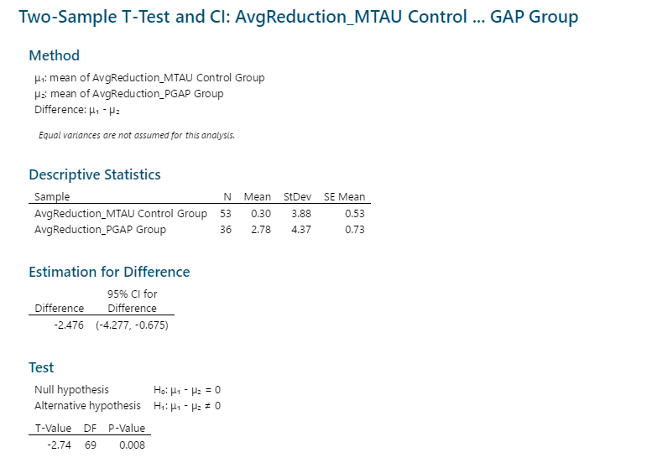

Table 4: Two sample T-test

**Average Reduction of 2.78 in Pain Score was observed for PGAP group of patients ranging from 1.29 to 4.25 at 95% confidence interval. P-value of 0.001 which is less than 0.05 was observed and hence the Null Hypothesis was rejected and a significant reduction in pain score after treatment was concluded by the study.**

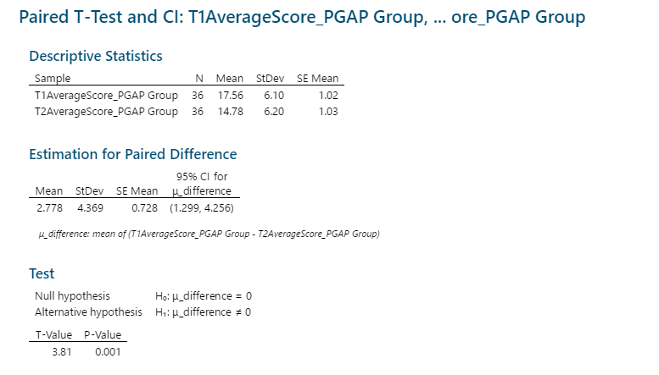

Table 5: Paired T-test

**Both subjective and formal analysis concludes that the treatment was successful in producing a significant reduction in pain for the PGAP group of patients.**

## **Dependence of success of treatment on Age and Gender of patients.**

The subjective analysis was carried out using a scatterplot of Age and Average Pain Reduction for both Males and Females. Formal analysis to analyze the dependency of Age and Gender over average pain score reduction was done using regression considering Average reduction as response and both Age and Gender as the independent variables for the analysis.

**No strong relation between Age and Average Reduction of pain score for both Males and Females was observed. However, regression line plotted on the scatterplot shows a slight positive relation between Age and Average reduction for males while for females the relation is negative. Which signifies that for Older male patients' reduction was more as compared to younger male patients while the scenario was reversed in the case of Females**



Figure 3: Scatterplot of AvgReduction vs Age grouped by Gender

**P-value (0.483) for Age and (0.614) for Gender was observed for the dependent variable of average reduction. Which are less than 0.05 and hence no significant relation can be assumed, and we can reject the Null hypothesis for both variables.**

Regression Analysis: AvgReduction versus Age, Gender

Method

|  |  |
| --- | --- |
| Categorical predictor coding | (1, 0) |

Analysis of Variance

|  |  |  |  |  |  |
| --- | --- | --- | --- | --- | --- |
| Source | DF | Adj SS | Adj MS | F-Value | P-Value |
| Regression | 2 | 18.76 | 9.382 | 0.52 | 0.599 |
| Age | 1 | 9.03 | 9.025 | 0.50 | 0.483 |
| Gender | 1 | 4.67 | 4.673 | 0.26 | 0.614 |
| Error | 86 | 1565.55 | 18.204 |  |  |
| Lack-of-Fit | 48 | 708.32 | 14.757 | 0.65 | 0.918 |
| Pure Error | 38 | 857.23 | 22.559 |  |  |
| Total | 88 | 1584.31 |  |  |  |

Model Summary

|  |  |  |  |
| --- | --- | --- | --- |
| S | R-sq | R-sq(adj) | R-sq(pred) |
| 4.26662 | 1.18% | 0.00% | 0.00% |

Coefficients

|  |  |  |  |  |  |
| --- | --- | --- | --- | --- | --- |
| Term | Coef | SE Coef | T-Value | P-Value | VIF |
| Constant | 3.04 | 2.24 | 1.36 | 0.177 |  |
| Age | -0.0318 | 0.0452 | -0.70 | 0.483 | 1.08 |
| Gender |  |  |  |  |  |
| Male | -0.52 | 1.04 | -0.51 | 0.614 | 1.08 |

Table 6: Regression analysis

The study concludes that with 95% confidence the reduction in pain after the treatment is independent of Age and Gender of the patients and hence the treatment is affecting patients of different age groups and gender in the same way.

## Effect of other illness on the success of treatment

For subjective analysis, a multiple pie chart was created to identify the proportion of the population with other illness in an individual group of patients. The formal analysis was done using a two-proportion test.

H0: Proportion of population with other illness is the same in two groups

HA: Proportion of population with other illness is not the same in two groups

For MTAU Control group 21.39% of people suffer from other illness while in PGAP group 38.9% of patients suffer from other illness. We can also see that there is no noticeable difference in the proportion of the population with other illness among the two groups.



Figure 4: Multiple pie chart- Proportion of other illness

The analysis shows that difference in the proportion of the population suffering from other illness is not significantly different in MTAU control and PGP group since 0 lies between the 95% confidence interval of (-0.199 to 0.2139). Also, from the p-value (0.975) which is greater than 0.05, we can gather evidence in favor of the NULL hypothesis and hence it cannot be rejected.

Test and CI for Two Proportions: otherillness_MTAU ... ss_PGAP Group

Method

|  |
| --- |
| Event: yes |
| p₁: proportion where otherillness_MTAU Control Group = yes |
| p₂: proportion where otherillness_PGAP Group = yes |
| Difference: p₁ - p₂ |

Descriptive Statistics

|  |  |  |  |
| --- | --- | --- | --- |
| Sample | N | Event | Sample p |
| otherillness_MTAU Control Group | 53 | 21 | 0.396226 |
| otherillness_PGAP Group | 36 | 14 | 0.388889 |

Estimation for Difference

|  |  |
| --- | --- |
| Difference | 95% CI for Difference |
| 0.0073375 | (-0.199300, 0.213975) |

*CI based on the normal approximation*

Test

|  |  |
| --- | --- |
| Null hypothesis | H₀: p₁ - p₂ = 0 |
| Alternative hypothesis | H₁: p₁ - p₂ ≠ 0 |

|  |  |  |
| --- | --- | --- |
| Method | Z-Value | P-Value |
| Normal approximation | 0.07 | 0.945 |
| Fisher's exact |  | 1.000 |

Table 7: Two proportion test

The analysis concludes that there is no significant difference in the proportion of the population with other illness in the two groups of patients. Hence, we can say that other illness is not affecting the treatment of pain in the PGP group of patients. And the treatment was successful in reducing pain regardless of the presence of other illness in the patients.

## Impact of pain on Employment Status of patients

Categorized employment status column was plotted and analysis is performed on the proportion of the population having High, Low or No impact on the employment.

Pain has a huge impact on the employment status of the patients and hence the success of treatment created a huge impact on the society. 65 or 73.0% of the patients reported being jobless or on sick leave due to pain thus impacting their employment on a larger scale. 1 of the patient was still working full time at time interval T1 and hence pain didn't have much effect on the patient's employment.





Figure 5: Bar graph of Impact of pain on employment

Figure 6: Pie Chart of Impact of pain on employment

# Conclusion

The treatment was successful in significantly reducing pain in patients of various age groups and gender. The pain was having a huge impact on patient's ability to perform full-time employment; Thus the treatment will be a boon for the society and can have a huge impact on patients life as with reduced pain patients ability to continue to work will improve.

# Appendix A: McGill Pain Questionnaire Sample

The McGill Pain Questionnaire Overview: The McGill Pain Questionnaire can be used to evaluate a person experiencing significant pain. It can be used to monitor the pain over time and to determine the effectiveness of any intervention. It was developed by Dr. Melzack at McGill University in Montreal Canada and has been translated into several languages.

Sections:

(1) What Does Your Pain Feel Like?

(2) How Does Your Pain Change with Time?

(3) How Strong is Your Pain? What Does Your Pain Feel Like?

Statement: Some of the following words below describe your present pain. Circle ONLY those words that best describe it. Leave out any category that is not suitable. Use only a single word in each appropriate category - the one that applies best (University, 2015).

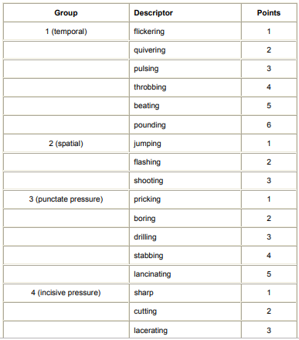

Full Questionnaire can be found at:

<https://www.gem-beta.org/public/DownloadMeasure.aspx?mid=1348%20>

# Appendix B: Roland Morris Disability Questionnaire Sample

Below is the sample of Rolland Morris questionnaire.

As you read the list, think of yourself *today*. When you read a sentence that describes you today, put a tick against it. If the sentence does not describe you, then leave the space blank and go on to the next one. Remember, only tick the sentence if you are sure it describes you today.

I stay at home most of the time because of my back.

I change position frequently to try and get my back comfortable.

I walk more slowly than usual because of my back.

(RMDQ, 2018)

# 

# Appendix C: Data Sample

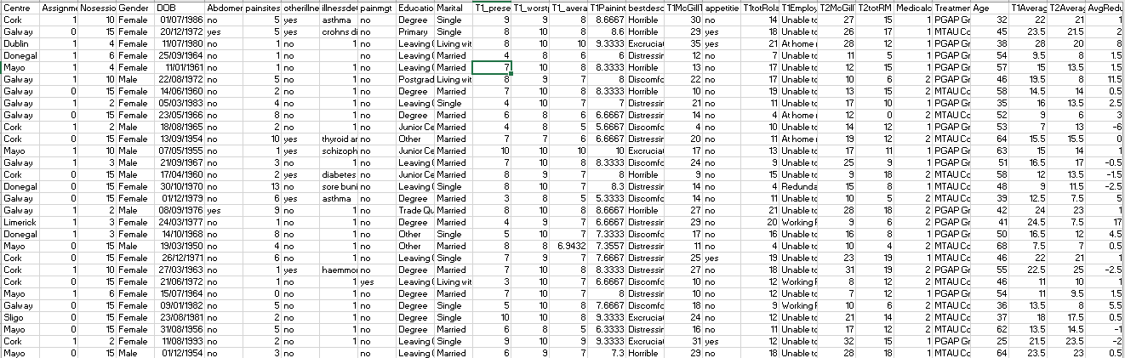

# Appendix D: Categories of Employment Status

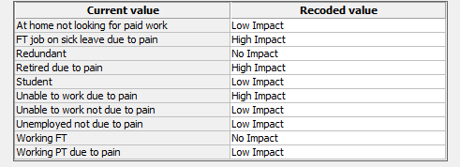

# Appendix E: Data Manipulation report

#----- Below Code is used to manipulate given data set ----------------------#

#----------------------Installing Packages-----------------------------------#

install**.**packages**(**"lubridate"**,** dependencies **=** T**)**

install**.**packages**(**"dplyr"**,** dependencies **=** T**)**

install**.**packages**(**"eeptools"**,** dependencies **=** T**)**

#-----------------------Loading Packages-------------------------------------#

library**(**lubridate**)**

library**(**dplyr**)**

library**(**eeptools**)**

#-----------------------Reading CSV------------------------------------------#

Pain **<-** **read.**csv**(**"Pain_Full.csv"**)**

Pain **<-** Pain **%>%**

**select** **(**ID**,** Centre**,** Assignment**,** Nosessions**,** Gender**,** DOB**,** Abdomen**,** painsites**,** otherillness**,** illnessdetails**,** painmgt**,** Education**,** Marital**,** T1_presentpain**,** T1_worstpain**,** T1_averagepain**,** T1Painintensity**,** bestdescribes**,** T1McGillTot**,** appetitie**,** T1totRolandMorris**,** T1Employment_final**,** T2McGillTot**,** T2totRM**,** Medicalcard**,** Treatment**)**

#-----------------------Data Cleaninig---------------------------------------#

#verify the **structure** **of** **data** **and** see **if** it looks good

str**(**Pain**)**

# We noticed **column** DOB **is** **in** **character** **format** but it should be **date,** converting DOB **to** **date**

Pain$DOB **<-** dmy**(**Pain$DOB**)**

summary**(**Pain**)**

#Filter **all** records **where** Pain score **is** **not** recorded **after** the treatment**.**

Pain **<-** Pain **%>%**

filter**(!is.**na**(**T2McGillTot**))**

#Fill **in** average pain **and** pain intensity **of** NA **rows** **with** average **values**

Pain$T1_averagepain**[**which**(is.**na**(**Pain$T1_averagepain**))]** **<-** mean**(**Pain$T1_averagepain**,** na**.**rm **=** **TRUE)**

Pain$T1Painintensity**[**which**(is.**na**(**Pain$T1Painintensity**))]** **<-** mean**(**Pain$T1Painintensity**,** na**.**rm **=** **TRUE)**

#Fill **in** 0 **for** MedicalCard **where** valur **is** NA

Pain$Medicalcard**[**which**(is.**na**(**Pain$Medicalcard**))]** **<-** 0

#verify the above processing

summary**(**Pain**)**

#------------------------Derived COluns-------------------------------------#

#Calculate age **from** the DOB **column**

Pain$Age **<-** **floor(**age_calc**(**Pain$DOB**,** units **=** "years"**))**

#Calculate T1AvgScore **And** T2AvgScore

Pain$T1AverageScore **<-** **(**Pain$T1McGillTot **+** Pain$T1totRolandMorris**)/**2

Pain$T2AverageScore **<-** **(**Pain$T2McGillTot **+** Pain$T2totRM**)/**2

#Calculate Average Reduction Pain Score reduction

Pain$AvgReduction **<-** Pain$T1AverageScore **-** Pain$T2AverageScore

#------------------------Write CSV-------------------------------------#

**write.**csv**(**Pain**,** **file=**"Pain_Clean.csv"**)**

Detailed report with output is attached for reference.



Cleaned Dataset



# Appendix F: Descriptive analysis for Primary Analysis

**Statistics**

|  |  |  |  |  |  |  |  |  |  |
| --- | --- | --- | --- | --- | --- | --- | --- | --- | --- |
| Variable | N | N* | Mean | SE Mean | StDev | Variance | Minimum | Q1 | Median |
| AvgReduction_MTAU Control Group | 53 | 0 | 0.302 | 0.534 | 3.885 | 15.090 | -7.500 | -1.500 | 0.500 |
| AvgReduction_PGAP Group | 36 | 0 | 2.778 | 0.728 | 4.369 | 19.092 | -6.000 | 0.125 | 1.500 |

|  |  |  |
| --- | --- | --- |
| Variable | Q3 | Maximum |
| AvgReduction_MTAU Control Group | 1.250 | 12.000 |
| AvgReduction_PGAP Group | 5.500 | 17.000 |

# References

RMDQ. (2018). *Roland Morris Disability Questionnaire*. Retrieved from http://www.rmdq.org/: http://www.rmdq.org/

Wikipedia. (2018, May 02). *McGill Pain Questionnaire*. Retrieved from www.wikipedia.org: https://en.wikipedia.org/wiki/McGill_Pain_Questionnaire